Project Design Phase-II

**Technology Stack (Architecture & Stack)**

|  |  |
| --- | --- |
| **Team ID** | **PNT2022TMID26073** |
| **Project Name** | **IOT Based Smart Crop Protection System For Agriculture** |

Technical Architecture:

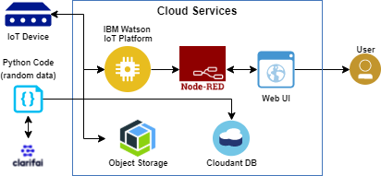

Table-1 : Components & Technologies:

|  |  |  |  |
| --- | --- | --- | --- |
| **S.No** | **Component** | **Description** | **Technology** |
| 1. | User Interface | Interacts with IOT Devices | HTML, CSS, JS |
| 2. | Application Logic-1 | Logic for a process in the application | Python |
| 3. | Application Logic-2 | Logic for a process in the application | Clarify |
| 4. | Application Logic-3 | Logic for a process in the application | IBM Watson Assistant |
| 5. | Database | Data Type, Configurations etc. | MySQL, NoSQL, etc. |
| 6. | Cloud Database | Database Service on Cloud | IBM DB,IBM Cloud etc. |
| 7. | Infrastructure (Server / Cloud) | Application Deployment on Local System / Cloud Local Server Configuration:  Cloud Server Configuration : | Local, Cloud Foundry, Kubernetes, etc. |
| 8. | File Storage | File Storage requirements | IBM block storage or other storage service or local file system |
| 9. | External API-1 | Purpose of external API used in the application | IBM weather API etc., |
| 10. | IOT Model | Purpose of IOT Model for integerating the sensors  with the user interface. | IBM IOT platform. |

Table-2: Application Characteristics:

|  |  |  |  |
| --- | --- | --- | --- |
| **S.No** | **Characteristics** | **Description** | **Technology** |
| 1. | Open-Source Frameworks | Open-source frameworks used | Python |
| 2. | Security Implementations | Authentication using encryption | Encryptions |
| 3. | Scalable Architecture | The scalability of architecture (3 – tier, Micro- services) | Web UI Application server-python, clarify database server-IBM cloud  services Technology. |
| 4. | Availability | It is increased by Cloud and database | IBM cloud services |

|  |  |  |  |
| --- | --- | --- | --- |
| **S.No** | **Characteristics** | **Description** | **Technology** |
| 5. | Performance | Design consideration for the performance of the  application (number of requests per sec, use of Cache, use of CDN’s) etc. | IBM cloud services |